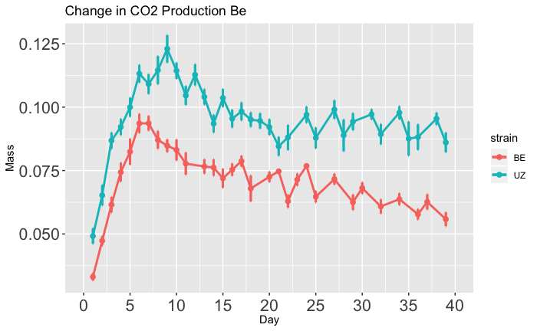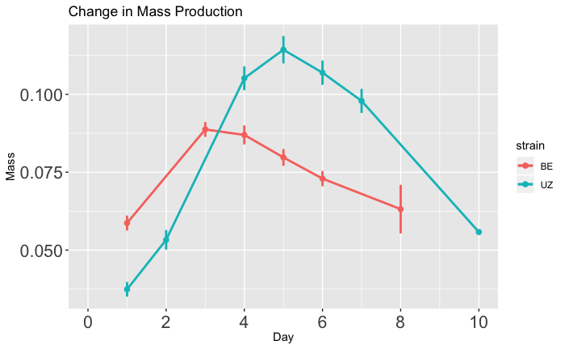

**B**

Mass (g)

Mass (g)

Time (days)

**Long-Diapause**

**Short-Diapause**

Time (days)

**Long-Diapause**

**Short-Diapause**

**A**